|  |  |  |
| --- | --- | --- |
| ClimEd  Multilevel Local, Nation- and Regionwide Education and Training in Climate Services, Climate Change Adaptation and Mitigation  619285-EPP-1-2020-1-FI-EPPKA2-CBHE-JP |  |  |

**D7.3. Dissemination Strategy**

|  |  |
| --- | --- |
| **Dissemination level** | International |
| **Due date** | 14.05.2021 |
| **Delivery date** | 15.05.2021 |
| **Work Package** | WP7. Dissemination & exploitation |
| **Type** | Service/Product |
| **Status** | Draft |
| **Version** | 0.3 |
| **Number of pages** | 24 |
| **Language** | English |
| **Abstract**  This particular document refers to the project’s strategy and plan for the dissemination of its results and it is organized as follows: Chapter 1 Introduction, Chapter 2 outlines the overall ClimEd dissemination strategy, Chapter 3 describes the ClimEd dissemination plan, Chapter 4 presents the ClimEd’s dissemination means and material, Chapter 5 outlines ClimEd dissemination events, Chapter 6 describe the reporting procedures, and Chapter 7 presents the Conclusions. | |

|  |  |
| --- | --- |
| The European Commission's support for the production of this publication does not constitute an endorsement of the contents, which reflect the views only of the authors, and the Commission cannot be held responsible for any use which may be made of the information contained therein. |  |

**Document history**

|  |  |  |  |
| --- | --- | --- | --- |
| **Version** | **Date** | **Reason** | **Revised by** |
| 0.1 | 15.04.2021 | Deliverable structure | All partners |
| 0.2 | 30.04.2021 | Contribution by partners | P04-OSENU, P01-UH, P07-LPNU, P09-ONMU |
| 0.3 | 15.05.2021 | Consolidated draft for review | P04-OSENU, P01-UH, P07-LPNU, P09-ONMU |
| 0.4 | 30.06.2021 | Internal review | Svyatoslav Tyuryakov (P01-UH) |
| 0.5 | 31.12.2021 | Revision after review | P04-OSENU |
| Enter version number. | Select a date. | Final version | Acronym(s) of organization(s) [e.g., P01-UH] |
| Enter version number. | Select a date. | Select an item and add rows as needed, if this is D7.3; otherwise delete the row. | Acronym(s) of organization(s) [e.g., P01-UH] |

**Author list**

|  |  |  |
| --- | --- | --- |
| **Organization** | **Name** | **E-mail** |
| P04-OSENU | Oleg Shabliy | foreign-relations@osenu.org.ua |
| P04-OSENU | Kateryna Husieva | kate.gusyeva@gmail.com |
| P04-OSENU | Artem Gamaiun | whitesanddd@gmail.com |
| P04-OSENU | Lidiia Popova | pl.95kh@gmail.com |
| P01-UH | Svyatoslav Tyuryakov | Svyatoslav.Tyuryakov@fmi.fi |
| P01-UH | Alexander Mahura | alexander.mahura@helsinki.fi |
| P07-LPNU | Myroslav Malovanyy | myroslav.mal@gmail.com |
| P09-ONMU | Tetiana Shablii | t_shabliy@hotmail.com |

**Table of Contents**

1. INTRODUCTION 4

2. DISSEMINATION STRATEGY 7

2.1. The Scope of the Dissemination Strategy 7

2.2. The Objectives of the Dissemination Strategy 7

2.3. Identification of Opportunities and Target Groups 7

2.4. Definition of Instruments and Media 11

2.5. Dissemination Material 11

2.6. Dissemination Management Roles, Committees and Tools 12

3. DISSEMINATION PLAN 14

3.1. Generic Guidelines 14

3.2. Approval Procedure 14

3.3. Events Participation 14

3.4. Presentations 14

3.5. Keeping the Website Up-to-Date 15

3.6. Conferences & Workshops 15

4. DISSEMINATION MEANS AND MATERIALS 15

4.1. Project Website 15

4.2. Project Presentation Template 16

4.3. Project Logo 17

4.4. Project E-Brochure 17

4.5. Project Leaflet 17

4.6. Project Posters 18

4.7. Project Roll-up Banners 18

4.8. Guidelines in the Form of E-Newsletters 19

5. DISSEMINATION EVENTS 20

6. DISSEMINATION REPORTING 20

6.1. Project Dissemination Report Template 20

6.2. Progress and Final Dissemination Report 21

7. CONCLUSIONS 21

Annex I. Dissemination reporting template 22

Annex II. Stakeholder list 23

1. INTRODUCTION

ClimEd is an EU funded project under Key Action 2 – ‘Capacity-Building in the Field of Higher Education’ of the Erasmus+ Programme, lasting 36 months, which aims at development of competency-based curricula for continuous comprehensive training of specialists in the field of climate services (CS) in Ukraine, as well as the initiation and development of additional education in climate change (CC) for decision-makers, experts in climate-dependent economic sectors (CDES) and the general public.

To that end the following specific objectives are set:

1. Development of competency-based concepts on professional education in the field of climate services and additional education for experts in climate-dependent economic sectors.

2. Development of teaching and methodological materials, elaboration of distance and blended learning courses in order to form methodological support for the continuous and comprehensive training of specialists in the field of climate services.

3. Development of blended learning courses in the field of climate change and adaptation to it for decision-makers, as well as massive open online courses in the same area for experts in climate-dependent economic sectors.

4. Development of massive open online courses in the field of climate change and adaptation to it for a wide public.

The project will have the following impacts:

1. Acquisition of European experience in the field of climate education, advanced educational and ICT technologies, as well as in the field of additional climate education and adapting the competency framework for climate services developed by the WMO Commission for Climatology, will be through trainings during the project, which will improve the international transparency and visibility of teachers and increase their professionalism.

2. Academic institutions-partners in Ukraine will be involved through direct participation: 1) in gathering end-user needs for climate information and 2) in the analysis of the current state of climate services, which will allow the scientific and pedagogical staff of specialized universities to create educational strategies that will be aimed at meeting the needs of certain end-users for climate information, will be flexible and easily adaptable to the needs of the modern labor market

3. Academic institutions-partners in Ukraine, thanks to close cooperation with European experts-developers of standards in the field of climate services, as well as with specialists in climate-dependent economic sectors, will be know much better the educational needs of climate-dependent sectors, better oriented in the unsolved practical tasks in the field of climate services facing the Hydrometeorological Service;

4. Sustainable and planned cooperation of the Consortium with the Hydrometeorological Service of Ukraine, climate-dependent economic sectors and other stakeholders through consultations, workshops, and trainings will make it possible to discuss the effectiveness of training programs and to quickly establish new training guidelines and to adapt training courses due to new needs or competencies in the operational work in relations with climate changes and the need to take them into account in climate-dependent economic sectors at the national level.

5. Hydrometeorological Service staff, specialists of climate-dependent economic sectors, decision-makers and policy-makers, business structures, financial organizations, all course-takers and foreign students who want to improve their skills will have access to a variety of courses, trainings, practices, teaching materials (including external international ones), and networking activities based on a research-and-education virtual platform, which will be an interactive network of Internet resources in the field of climate services.

6. Teaching staff at partner academic institutions will be involved through the engage of the courses development and review of curricula, developing of the structural parts of the courses, including for distance learning, conducting online and offline courses, as well as organizing educational and methodological seminars, trainings, and consultations aimed to exchange experiences in the academic structures of the consortium.

7. Teaching staff at partner academic institutions in Ukraine; students of various courses in the field of general and specialized climate services; students of various courses in the field of climate change, adaptation to climate change and mitigation; and foreign students will have access to numerous theoretical and applied scientific studies, in collaboration with industry-specific universities, subdivisions of the Hydrometeorological Service of Ukraine and other stakeholders, and will be involved in development and introduction of innovative educational resources and facilities, namely simulators, cases, projects with the assistance of specialists from partner universities, European experts and the faculty members of the University.

ClimEd dissemination strategy aims to create awareness among various stakeholder groups on the project, its progress and results.

Website featuring communication tools, including social media, will be established and promoted.

Established contacts will be collected and further used to organise stakeholder conferences for promotion of the learning environment and collecting feedback to update the dissemination strategy and ensure that the results of the project are appropriate and applicable to stakeholders.

The communication strategy is concerned with communicating the structure of ClimEd provision, including good practice guidance, to teachers, students and stakeholders.

This particular document refers to the project’s strategy and plan for the dissemination of its results and it is organized as follows:

* + - Chapter 1 Introduction
    - Chapter 2 outlines the overall ClimEd dissemination strategy
    - Chapter 3 describes the ClimEd dissemination plan
    - Chapter 4 presents the ClimEd’s dissemination means and material
    - Chapter 5 outlines ClimEd dissemination events
    - Chapter 6 describe the reporting procedures
    - Chapter 7 presents the Conclusions

The dissemination will be organized in three phases:

1. Early in the project, dissemination will ensure that the project is addressing the needs of its target groups, or is creating awareness or understanding of the project activities.
2. During the project, dissemination is about identifying lessons from what has been learned, particularly in relation to processes, and passing them on to key stakeholder groups.
3. At the end of the project, dissemination is intended to publicize more generally the project’s outputs (both products and processes), the lessons learnt, and the benefits gained both tangible and intangible ones.
4. DISSEMINATION STRATEGY

The dissemination of the project will be differentiated according to the target groups to which the project is addressed and according to the result which is being disseminated.

* 1. The Scope of the Dissemination Strategy

The proposed dissemination strategy lies on four basic public relations principles:

• Be visible: Stay proactive. Promote your objectives through media and community involvement. Build positive relationships with opinion makers.

• Be informed: Keep abreast of community issues, read papers, watch news. Attend the national and community policy making on the topic that you are concerned. Research the issue on the Internet.

• Be consistent: Stay on message. Right actions at the right place. Media can sometimes relish inconsistencies.

• Be constructive: Be part of the solution. Build personal relationships.

* 1. The Objectives of the Dissemination Strategy

Dissemination must be an integral part of the project activities as it will enable the consortium to reach the target group, get them actively involved, interested and motivated in order to:

• Get better and more precise results

• Get them interested to foster the project results

• Get the message out there

* 1. Identification of Opportunities and Target Groups

A careful mapping of specific opportunities and tasks has to be made in order to support the dissemination activities that will be performed during the ClimEd project. Therefore, a target group list has been constructed containing the initial areas sought for obtaining contacts and opportunities for collaboration and target groups for dissemination and post project end sustainability related activities. Although we will address all stakeholders, there are specific target groups upon which ClimEd dissemination and exploitation activities will be focused:

(1) **Academic institutions in UA**: faculty, students (master and doctoral students)

(2) **Hydrometeorological institutions in UA**: managers and personnel

(3) **Political and economic public bodies**

(4) **Experts in climate-dependent economic sectors**

(5) **Experts from municipal organizations**

(6) **The general public**

(7) **Entrepreneurial entities, banks, investors, insurers**

(8) **International students** wishing to improve their qualifications

Dissemination actions can be categorized in 4 levels (Tab. 1):

• **Dissemination for awareness**: we wish people to be aware of the work of our project. This may be useful for those target audiences that do not require a detailed knowledge of our work but it is helpful for them to be aware of our activities and outcomes. Creating such an awareness of our project’s work will help the ‘word of mouth’ type dissemination and help us build an identity and profile within our academic, professional and research community.

• **Dissemination for understanding**: there will be a number of groups / audience that the consortium needs to target directly with the dissemination. This will be because the consortium knows that they can benefit from what ClimEd project has to offer and also because it realizes that their involvement in the project will improve significantly its results.

• **Dissemination for support**: the project’s success lies in the support the consortium can get from the key audience and other stakeholders. Even if it delivers excellent results, if it does not get the support from participants of the academic process, professional community and/or authorities that can use the interactive learning courses, then all of the efforts will fall into void. It is important that people we want to eventually use our project’s results must be involved from the beginning, supporting our activities.

• **Dissemination for action**: ‘Action’ refers to a change of practice resulting from the adoption of results offered by the ClimEd project. Targeted audience for this type of dissemination are groups/audience that is in a position to ‘influence’ and ‘bring about change’ within their organisations. These are the groups/audience that will need to be equipped with the right skills, knowledge and understanding of the work in order to achieve real change.

In Ukraine a stakeholder network will be set up including stakeholders from the target groups listed above. Every partner will create a local stakeholder network which will be expanded as the project proceeds. A database will be created which will include the information provided. The database will be regularly updated by the partners to ensure that it is an on-going process attracting new community members. It will start from the beginning of the project and new organizations will be added as the project continues. In order to avoid mismatches on the final integration of the different national lists, a Stakeholders Network List Template is provided as Annex II of this document.

**Table 1. ClimEd dissemination actions by levels**

|  |  |  |  |
| --- | --- | --- | --- |
| *Purpose* | Activity | Target Audience/  Groups | Methods |
| *for awareness* | * Launching and regular update of project website * Project products development and implementation * Preparation and distribution of guidelines * PR campaigns aimed at promoting high quality climate services in particular field and high level training courses * Development and distribution of promotional materials | - Academic institutions in UA: faculty, students  - Hydromet. institutions in UA: managers and personnel  - Political and economic public bodies  - Experts in climate-dependent economic sectors and from municipal organizations  - The general public  - Entrepreneurial entities, banks, investors, insurers  - International students | * News * Electronic guidelines * Open communica-tion * Online publications |
| *for understanding* | * Regular announcements at workshops, seminars, and conferences * PowerPoint presentations at appropriate round tables and conferences on national and European level * News releases sent to journalists from the media * Links to other projects/initiatives on national and EU level * Info days or bilateral meetings with representatives of ClimEd target groups * Project news distributed through e-mail and regular mail * Articles published in online portals and search engines * Publications in specialised academic newsletters * Regular postings in social media | - Academic institutions in UA: faculty, students  - Hydromet. institutions in UA: managers and personnel  - Political and economic public bodies  - Experts in climate-dependent economic sectors and from municipal organizations  - The general public  - Entrepreneurial entities, banks, investors, insurers  - International students | * PowerPoint presentations * Reports * Articles * Radio and TV interviews * Networking * Social   media publications |

|  |  |  |  |
| --- | --- | --- | --- |
| *Purpose* | Activity | Target Audience/  Groups | Methods |
| *for support* | * Iterative testing of project outputs * Bilateral meetings with stakeholders and policy makers * Focus groups and/or panel sessions with target group representatives and other potential beneficiaries * Advisory group members’ involvement in networking with stakeholders * Meetings with regional community organisations | - Academic institutions in UA: faculty, students  - Hydromet. institutions in UA: managers and personnel  - Political and economic public bodies  - Experts in climate-dependent economic sectors and from municipal organizations  - The general public  - Entrepreneurial entities, banks, investors, insurers  - International students | * Question-naires * Open   interviews   * Personal invitations * Face to face communica-tion * Memoranda of understand-ing * Joint dissemination events |
| *for action* | * Promotion and exploitation of the ClimEd products among the partner countries and involvement of non-participating countries * Mainstreaming of ClimEd results among stakeholders and gatekeepers | - Academic institutions in UA: faculty, students  - Hydromet. institutions in UA: managers and personnel  - Political and economic public bodies  - Experts in climate-dependent economic sectors and from municipal organizations  - The general public  - Entrepreneurial entities, banks, investors, insurers  - International students | * Liaison closely with key stakeholders * E-mail shots * Networking * Signed cooperation agreements |

* 1. Definition of Instruments and Media

Dissemination activities will be performed through various instruments and media. These will be carefully selected for facilitating collaboration among involved parties, i.e. bidirectional flow of knowledge, promoting the project and its results in a unidirectional informative manner, providing targeted or generic information and allowing the provision of feedback and suggestions / requirements raised by target groups such as hydrometeorology professionals, academic community and versatile stakeholders. The main instruments and media which will be used fall within the following areas:

* + Events;
  + Publications;
  + E-Media;
  + Social Media.

**Events** refer to both collaboration and dissemination and include participation in, or organization of:

* + Bilateral meetings;
  + Presentations at conferences;
  + Workshops for the key stakeholders;
  + Exhibitions;
  + Training events;
  + Networking sessions;
  + Specialized events.

**Publications** refer to both electronic and printed media. They include:

* + Press releases;
  + Short articles published on the Internet or in journals and relevant magazines;
  + E-newsletters and other information material produced by the partners and disseminated through the internet (including publications in social networks etc.).

**E-media** is primarily concerned with the project’s website and the services made available there and includes:

* + Content published on ClimEd website;
  + Content published on the partners’ institution/establishment websites about ClimEd project.

**Social media** refers to the project’s page on Facebook (https://www.facebook.com/groups/climed.network) and Twitter (https://twitter.com/ClimedErasmus?fbclid=IwAR2HdjYozgSSEqm81OBkGltZHF1iJSquhRMzhM

pWM8LkIna2hr0a8E7TXSg).

* 1. Dissemination Material

An important stage in the context of the ClimEd plan is the production of promotional materials. Examples of dissemination materials, already produced, include:

* + Presentation Template (for further information see section 4.2.)
  + Dissemination Report (Internal Project Management document) – Annex I
  + Project logo (for further information see section 4.3)
  + Project e-brochure (for further information see section 4.4)
  + Project leaflet (for further information see section 4.5)
  + Project posters (for further information see section 4.6)
  + Project roll-up banner (for further information see section 4.7)
  + Guidelines in the form of e-newsletters (for further information see section 4.8)
  1. Dissemination Management Roles, Committees and Tools

Each partner based on its role in each WP will support the dissemination activities by:

* + Producing dissemination materials;
  + Contributing to the newsletters, website and social media content;
  + Managing the means / tools to support dissemination activities ;
  + Coordinating and managing the relevant activities that deal with the partner’s work or application field on the project;
  + Managing the partner’s internal inter-organizational dissemination issues;
  + Organizing events.

WP 7 leader – P4 / the Dissemination Manager (DM) will be subordinated directly to the Coordinator of the project, will steer and supervise all dissemination and sustainability activities. The DM of the project will be responsible for the coordination of dissemination activities throughout the project in cooperation with the Project Coordinator and the Consortium as a whole. The DM will have to deal with the following aspects of the project:

* + Coordinating the dissemination activities in the project ;
  + Drafting and updating the dissemination plan;
  + Organizing and chairing dissemination events;
  + Reporting on dissemination to the Project Consortium;
  + Producing newsletters using the contribution by all partners;

The main electronic means / tools to assist these activities are as follows:

* + The project web-portal.
  + Mailing lists including all partners as appropriate.
  + Social media websites where the project can be advertised
  + Organizations’ websites, where the project must be advertised and links should be provided to the main project website.

**The ClimEd web-site and Distance Learning (DL) Portal** will be the main communication tools. They will contain project news, announcements, surveying tools, document repositories, & links to e-services that will serve as a dissemination platform for target groups. All the partner institutions (PIs) will be contributing to the development of contents. WG7.1 and WG7.2 will monitor the updates and ensure that all the target groups are addressed.

**Social media** (Twitter, FB) will be exploited starting M3. PIs will hold responsible for media coverage of ClimEd events they are involved to. ClimEd newsletters and social media presence will last after the end of the project.

To ensure the most effective dissemination of results diverse dissemination channels are planned:

1) Ad hoc Intensive:

- the ClimEd web-site will be launched and developed by WG7.1 (M03-M36), with the project news items and the materials from the project workshops uploaded regularly; all the academic PIs will maintain and update a dedicated project web-page;

- the e-brochure on the project will be circulated among PIs and beyond the consortium;

- two e-posters, layout originals for leaflets, posters and banners will be developed to be further published at the expense of internal resources of HEIs;

- guides and instructions for development of new study programmes compatible with WMO standards, adapted Competency Framework for Provision of Climate Services and climate service user’s requirements in Ukraine will be distributed to the HEIs in the form of e-newsletters.

- analytical reports and analyses of best practices will be circulated among the sectoral Universities, Ministry of Education and Ministry of Energy and Environment Protection and beyond;

- moderation of online forum discussions on project issues and deliverables, media coverage for important ClimEd events and deliverables in the institutional, local and national media will be ensured, incl. coverage in the social media (FaceBook, Twitter). The media coverage of the project events will be monitored by WG6.3 and reported to the Steering Committee twice a year.

2) Ad hoc Extensive:

WG7.2 will coordinate development of the project DL Portal (starting M2), containing the e-learning courses/modules developed under WP3, compatible with WMO standards, adapted Competency Framework for Provision of Climate Services and climate service user’s requirements in Ukraine (M25).

3) Embedded – the relevant Ministry of Education and Ministry of Environmental Protection and Natural Resources of Ukraine (M08,12,16,20) will disseminate project results during annual conferences and other activities resulting from the status of these organizations. Thus, sustainability of the project results will be ensured as these partners will not cease carrying out dissemination activities upon the end of the project.

WG7.3 is in charge of development of the strategies for dissemination and exploitation, that will encompass the range of dissemination and exploitation activities during the project lifetime to ensure the post-project sustainability, and provide details on how the project deliverables will be maintained upon the end of the project. The in-project Strategy for Dissemination will be developed by M02, the project Strategy for Exploitation/Sustainability - by M06 and the post-project Strategy for Exploitation/Sustainability and Dissemination - by M30.

WG7.4 will coordinate the wider outreach activities through information seminars, open international calls for ClimEd training events, stakeholder roundtables, business-academy conferences, dedicated ClimEd panels on conferences organised by PIs and arranging follow-up special issues of academic journals in order to reach the academic community. The HEIs, Ministry of Education and Ministry of Environmental Protection and Natural Resources, organizations acting as stakeholders, representatives of the general public and mass media will be involved in the activities.

1. DISSEMINATION PLAN
   1. Generic Guidelines

The following is a generic set of guidelines for the dissemination events and materials:

• Intentions to perform any primary dissemination activity are generally required to follow the procedure described below; using the referenced tools (global mailing lists, WP lists, etc.).

• Partners should not initiate ClimEd dissemination activities on topics that fall outside of their involvement in the project.

• All publicly held activities should present their material in electronic form to the rest of the consortium.

* 1. Approval Procedure

It has been agreed that no partner will have to ask prior consent for any dissemination activity planned, but all partners are obliged to inform the consortium and the DM on any important planned dissemination activity (such as participation in a big conference etc.) prior to the dissemination activity.

Always mind the planned and approved budget allocated for the realisation of dissemination activities. In case of activities not included in the workplan or participation in events outside of the project partners’ countries requires approval by the Project Coordinator and consent by the EACEA’s Project Officer.

* 1. Participation in Events

Once a partner receives information on an up-coming conference, workshop, etc., the concerned partner should inform the consortium of the upcoming event by sending an email to the mailing list, only when the event could be relevant also to the other partners. The material presented by the participant should be reported in a Quarterly Dissemination Report that each partner must compile every three (3) months and send it to the Dissemination Manager.

* 1. Presentations

Performing ClimEd related presentations in various events is a task that might be carried out by every partner, for own exploitation and publicity. The partner must comply with the following:

* + The presentation should indicate the ClimEd logo.
  + The presentation should identify the funding disclaimer of the project.
  + The presentation has to be produced following the ClimEd presentation template.
  + Presentations should conform to the EU rules for publications.
  + A presentation template will be produced listing all of the above plus some standard slides to be inserted in all Consortium presentations of the project. Further information can be found in section 4.2.
  1. Keeping the Website Up-to-Date

Consortium members are the main source of information and the ones responsible for adding content. The structure and configuration of the website is modified upon recommendation by partners, or as needed by the Website Administrator for facilitating navigation and access to information.

* 1. Conferences & Workshops

Conferences and workshops on thematic areas relevant to the project will be carefully tracked down by all partners and upon availability the consortium will generate papers and presentations to be made to them.

1. DISSEMINATION MEANS AND MATERIALS

During the execution of the dissemination plan both traditional and innovative media are going to be used in order to maximize the impact and the visibility of the project.

* 1. Project Website

Fully functional and user friendly web site (Fig 1) has been designed and will serve as a major dissemination tool (website address: http://climed.network/). The aim of the website is to promote the project’s objectives, provide information on the project’s progress, publish the results and showcase the work done by the partners. It will constitute the most versatile information and communication tool. On one side it will give the opportunity to provide information for a worldwide audience and on the other side it will enable a comprehensive provision of information. The website will include information on the project, its objectives, its partners and expected results and other documents (such as presentations, public deliverables and reports).

The website will ensure the successful use of project results and non-confidential information to the widest possible audience (including immediate target groups and other relevant interested parties). The aim of the website is primarily to inform the general public about the ClimEd project and additionally to constitute a tool to communicate and to exchange information on the project between partners. The website will contain information relevant to the project, the field, the partners, news of the sector and will contain relevant links.

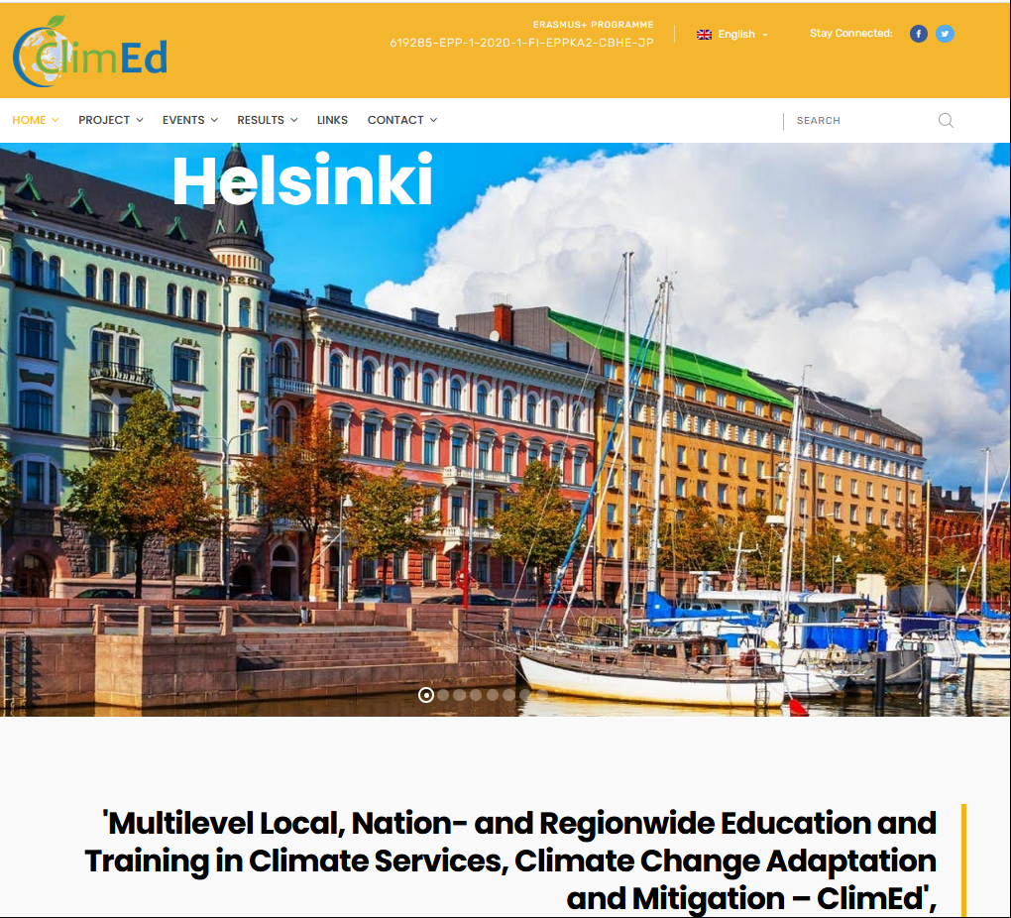

Fig. 1 Homepage of ClimEd project website

* 1. Project Presentation Template

As a general overview of the project and its objectives, presentations will be produced. The content of the presentations will describe the general objectives of the project, the participating organizations and give an outlook on the intended functionality of the system and the ways the project tasks are performed. The presentations can be used by all partners at a starting point and can be enriched based on the needs of the partners and the peculiarities of the dissemination events. Based on this material, a presentation will be produced at the end of the project in order to sum up the final results.

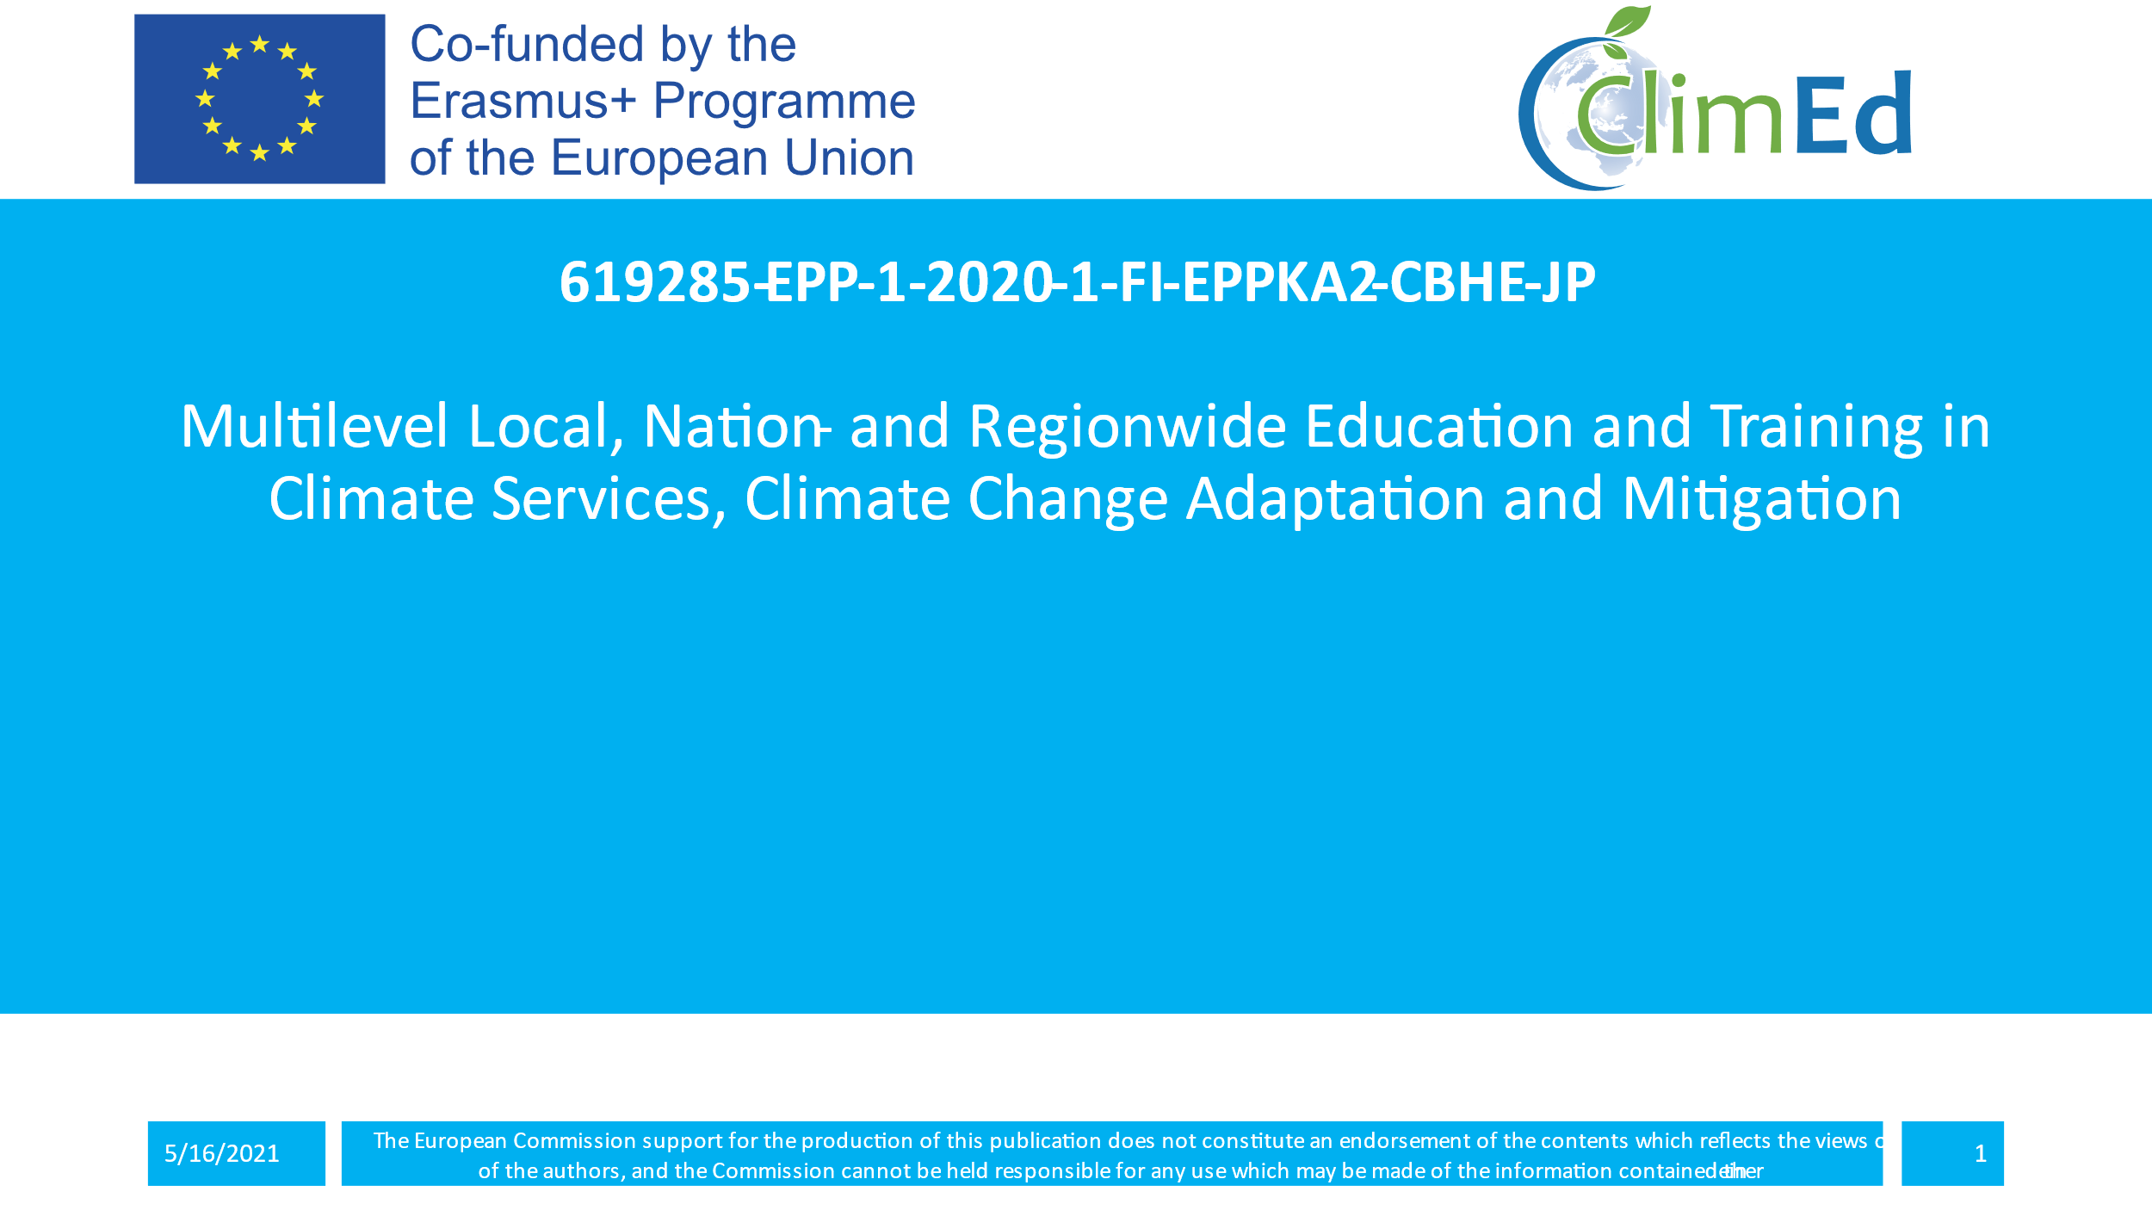 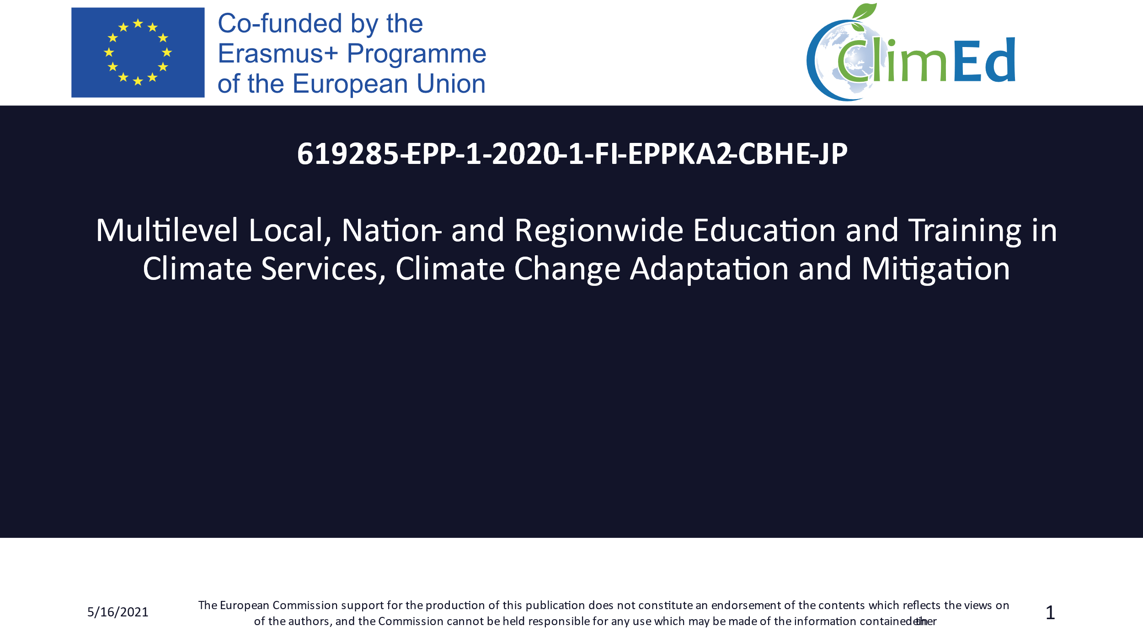

Fig. 2 PowerPoint template (2 versions)

* 1. Project Logo

The project logo has been designed and approved by all partners.



Fig. 3: Project Logo

The project logo will be used in all future dissemination material in order to ensure that members of the target groups will get familiar with this logo and will directly link it to ClimEd project. This logo can as well serve as product logo later in the post-project phase.

* 1. Project E-Brochure

The e-brochures on the project are to be developed (the first one - by M10 and the second - by M36) and circulated among PIs and beyond the consortium.

* 1. Project Leaflet

A project leaflet in English is to be produced (the first one – by M6 and the second – by M34) additionally in order to help effectively the dissemination activities. It is a tri-fold brochure, providing general information about the project, its objectives, and expected results and about the consortium. The target will be the distribution of 1000 copies.

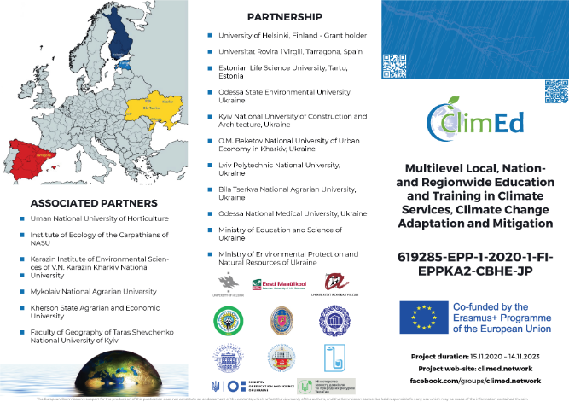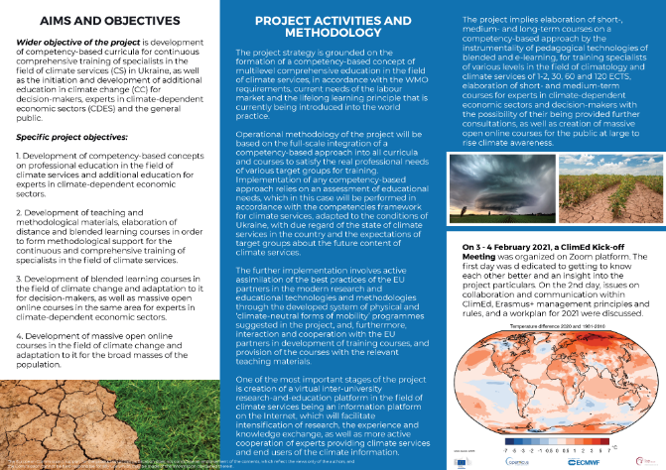

Fig. 4: Main and back pages of the English leaflet

* 1. Project Posters

Two e-posters and layout originals for posters (the first one – by M6 and the second – by M34) are to be developed and published.

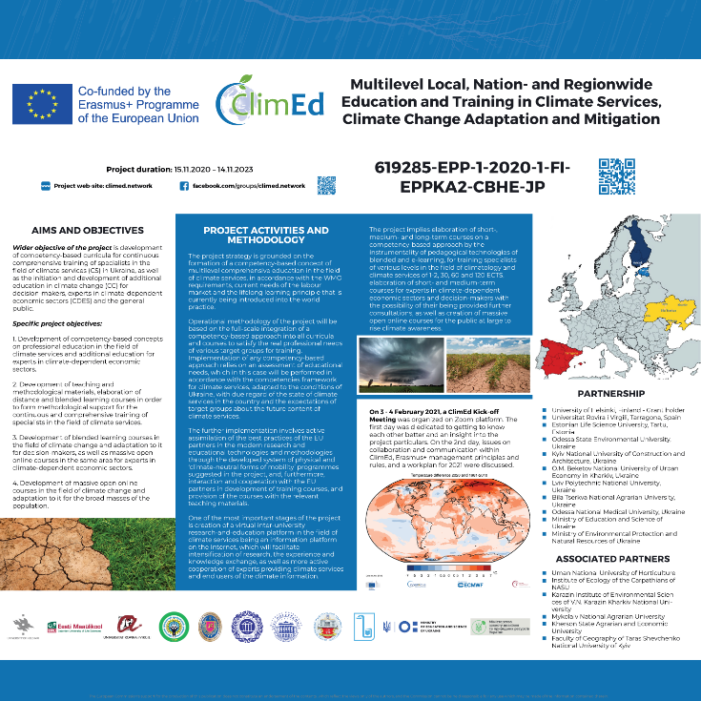

Fig. 5: Poster #1

* 1. Project Roll-up Banners

Project roll-up banners (the first one – by M6 and the second – by M34) are being produced in order to give an additional effective aid to the dissemination activities. The project’s banners contain the very basic information about the project. They emphasizes the multilateral international identity of the project and draw the attention of the stakeholders due to the expertise of the consortium. The target is to visualise the project during thematically related events. They are to be produced in 1 sample in each version.

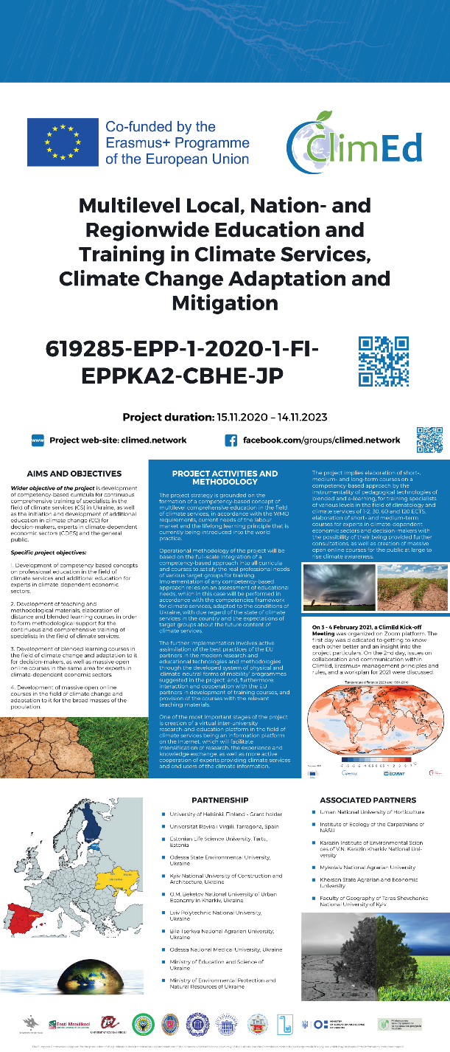 Fig. 6: Roll-up banner

* 1. Guidelines in the Form of E-Newsletters

Guides and instructions for development of new study programmes compatible with WMO standards, adapted Competency Framework for Provision of Climate Services and climate service user’s requirements in Ukraine are to be distributed to the HEIs in the form of e-newsletters. In addition, analytical reports and analyses of best practices developed under other WPs are to be circulated among the sectoral Universities, Ministry of Education and Ministry of Environmental Protection and Natural Resources and beyond.

A short ‘to the point’ newsletter can keep the target audience informed of progress and continue to stimulate interest and increase participation. During the project five (5) newsletters will be prepared. The partners will distribute each of them to the stakeholders every six months. The information will be complimentary to the information and feedback that will be requested by them during the project performance.

1. DISSEMINATION EVENTS

Three main types of activities can be identified, according to the aiming target group. Specifically:

* + Dissemination events for **professionals / practitioners**
  + Dissemination events for **participants of the academic process**
  + Dissemination events for **policy makers and other stakeholders**

Dissemination events include, among others, the organization of **Information Seminars** by the project’s partners with the participation of at least 15 participants. Each UA partner will be responsible of organizing **stakeholder roundtables** in accordance with its foreseen budget with the aim to inform stakeholders and potential users on the results of the project. The project’s partners are encouraged to organize more informal dissemination meetings with the target groups mentioned during the project for which additional reporting will be provided accordingly. The results from the seminars will be included in the Semi-annual Dissemination Report of that period.

Project activities can be presented at **dedicated ClimEd panels on conferences organised by PIs**, and **business-academy conferences**, that are either organized by the project team or by third parties who are willing to host a presenter from the ClimEd project team. Conferences can be a very useful forum to consult with our target audiences in a face-to-face capacity and to address issues relevant to the work of our project.

**The follow-up special issues of academic journals** will also be arranged in order to reach the academic community.

**One-to-one conversations and meetings** proved to be very useful to target key people who will enhance the chances of success of our project.

The media coverage of the project events will be reported to the Steering Committee twice a year.

1. DISSEMINATION REPORTING
   1. Project Dissemination Report Template

In order to keep track of all dissemination activities, a Quarterly Dissemination Report template (Annex I) is available for all partners. Every three (3) months each partner should fill a Quarterly Dissemination Report including a detailed description of every Dissemination Activity that took place during that period and send it to the Dissemination Manager. Each partner must collect evidence such as screen shots, photos, list of participants (compulsory if the costs are covered by the project), agenda, info-packs etc. duly indicated in English description and reference number included in the template. In this way, ClimEd will keep track of the effectiveness of dissemination and of all parties reached via the project.

* 1. Progress and Final Dissemination Report

The dissemination reports describing all the dissemination activities of the project realized in the previous period will be prepared by the Dissemination Manager after receiving all relevant information and evidences from the other partners in the requested format. The Semi-annual Dissemination Reports will form the basis of the preparation of the Progress and Final Dissemination Reports.

In accordance with the Grant Agreement, the co-ordinator must use Erasmus+ Project Result Platform, on the website http://ec.europa.eu/programmes/erasmus-plus/projects/ to disseminate project results and deliverables in accordance with the instructions provided therein. The approval of the final report will be subject to the upload of the project results/deliverables on the aforementioned platform by the time of its submission.

1. CONCLUSIONS

The dissemination strategy and plan aim to capture and schedule all dissemination relating activities of the project which will support the widening of the user-base and will increase public awareness of the new possibilities that are arising from the ClimEd products.

The dissemination planning assists ClimEd project partners by defining communication goals, objectives and strategies with specified dissemination events to participate and dissemination activities to perform. The overall aim is to obtain a reputation that is consistent with the objectives of the ClimEd project.

Concluding, all the partners as a consortium and each one of them individually must bear in mind that they should aim to disseminate the project in any relevant public presence (like conferences, seminars, meetings, etc.) using the materials and means described in this document.

Annex I. Dissemination reporting template

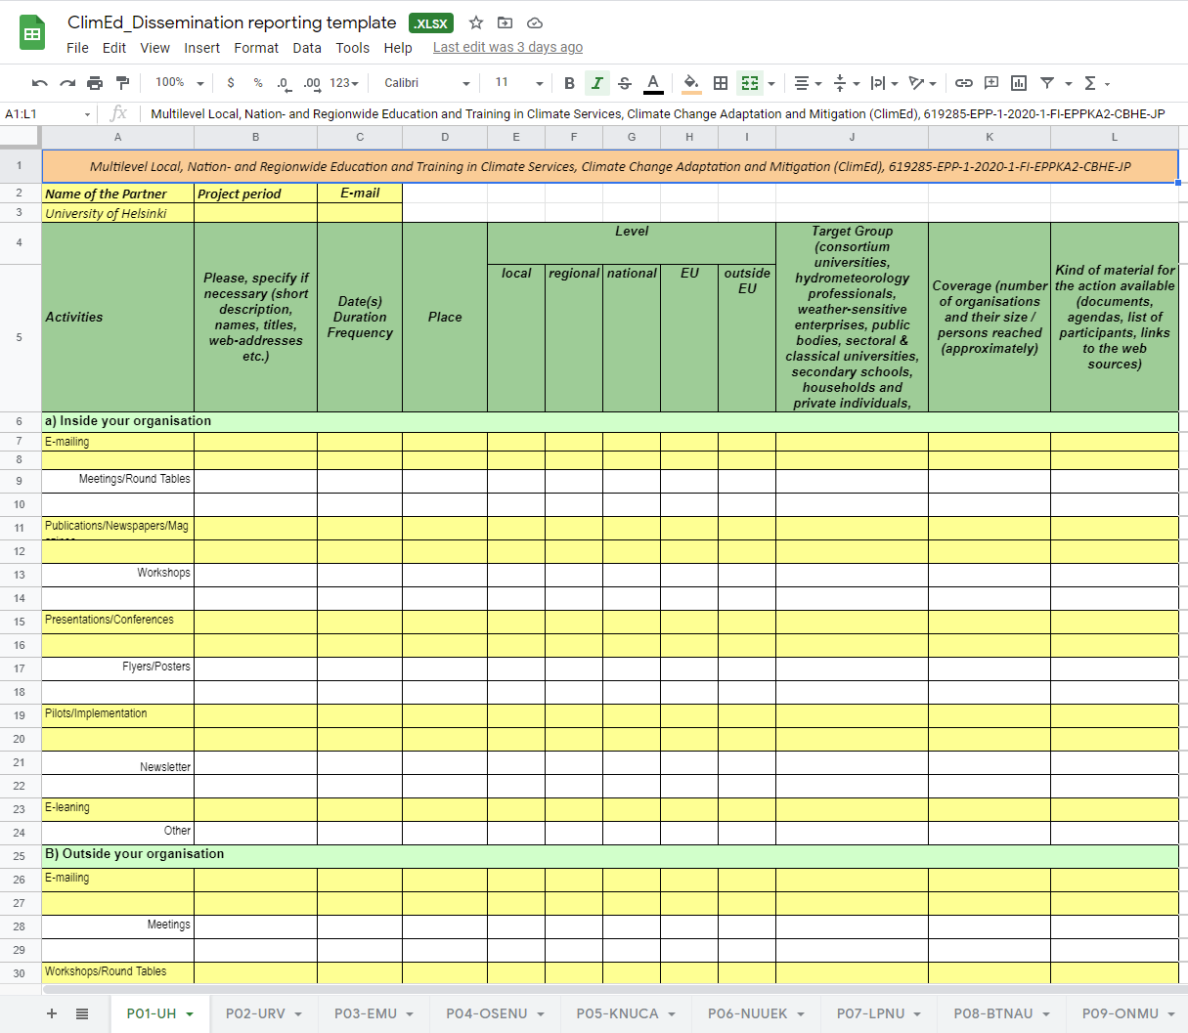

**Guideline:**

* + Please fit in a new row if you have several activities in the same field!
  + Be realistic because your information will be the basis to build up the project’s dissemination strategy!
  + Contact us whenever you have any questions!

Thank you for your cooperation!

Contact us: [foreign-relations@osenu.org.ua](mailto:foreign-relations@osenu.org.ua)

Annex II. Stakeholder list

